Requirements for the Preparation of Articles for the CILTEM 2025 Conference Proceedings

General information
Articles in the conference proceedings are published in either Lithuanian or English. However, articles submitted by foreign authors must be written in English. Authors are required to submit an electronic version prepared in MS Word using Times New Roman font, following the formatting requirements outlined below. The article text must be single-spaced on A4 format pages (210 × 297 mm). The length of the article should not exceed 10 pages. The electronic version must include the following brief author information: academic degree, current position, field of scientific interest (applied research), workplace and its address and e-mail address.

Structure of the article
The article must include title, name(s) and surname(s) of the author(s), name and address of working place or organization, abstract in Lithuanian, keywords and an introduction. The introduction should define the research object and aim, outline the tasks, describe the applied methods, state the problem, justify the relevance of the topic, and include a literature review and analysis. The main body should present the development of the topic, research results, and their interpretation. The article must end with conclusions and a list of references. At the end of the article, an abstract in a foreign language (English or Lithuanian, depending on the article’s original language) must be provided. This abstract should be at least 1500 characters long (excluding spaces).

Formatting of the text
1. The article must be written using MS Word for Windows, in Times New Roman, 12 pt font, with single line spacing (1.0). Page format: A4 (210 × 297 mm), vertical orientation. Margins: left – 30 mm, right – 10 mm, top – 20 mm, bottom – 20 mm.
2. The title of the article should be written in bold, 14 pt, uppercase letters, cantered. Leave one blank line between the title and the author’s name.
3. The name(s) and surname(s) of the author(s) should be written in bold, lowercase letters, centred.
4. The name and address of the author’s workplace or organization, as well as the e-mail address, should be written in italics, 10 pt, lowercase letters, centred. Leave one blank line between the author's name and the name of the workplace.
5. The abstract should be written in 10 pt, normal font, with justified alignment.
6. Keywords should be written in 12 pt.
7. The main text of the article must be written in 12 pt, with justified alignment.
8. The body of the article should be divided into sections and subsections. Section titles must be in bold, 12 pt, lowercase letters, aligned to the left. Subsection titles should follow the same formatting.
9. Paragraph style: the first line should be indented by 1.25 cm; spacing after paragraphs should be set to 3 pt. All paragraphs should have justified alignment, with text aligned to both left and right margins.
10. Formulas, tables and figures:
Formulas must be written using the standard Word equation editor. The font size for main variables should be 10 pt, and variables and their indices (except numbers) must be in italics. All formulas must be centred on the page and numbered consecutively throughout the text using Arabic numerals in italic format, enclosed in parentheses—for example, (1), (2), and so on. The formula number should be aligned to the right margin.

$f_{cd}=α_{cc}∙\frac{f_{ck}}{γ_{c}}$ (1)
Where: f_{cd} - design compressive strength of concrete (MPa); α_{cc} - coefficient considering long-term effects on compressive strength; f_{ck} - characteristic compressive strength of concrete at 28 days (MPa); γ_{c} - partial safety factor for concrete.

Tables must be formatted within the text, using justified alignment. Table numbers and titles should be written above the table, in italics, 12 pt, and numbered consecutively throughout the article (e.g., Table 1. Title). The content inside the table should be aligned to the left and written in 10 pt font.

Table 1. Title
AAAAA | BBBBBBB | AB | CCCC

Illustrations, pictures, diagrams, and similar visual elements must be inserted within the main text and also submitted as separate files. Pictures and photographs must be in TIFF or JPG format with a minimum resolution of 300 DPI, using greyscale tones.
Graphs, drawings, and diagrams should be submitted in EPS, WMF, or EMF formats (formats generated using Excel or CorelDRAW are also acceptable).
Titles of illustrations must be written in 12 pt bold font, centred, and numbered consecutively throughout the text (e.g., Figure 1. Title, Figure 2. Title). The title should be placed after the figure number, on the same line, with centre alignment.

Figure 1. Title
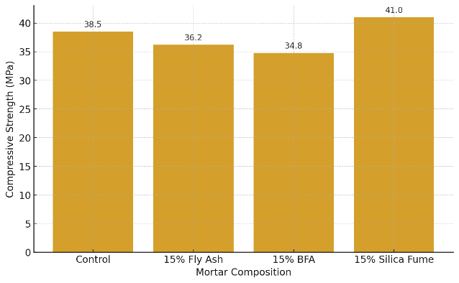
11. Reference list
All references must follow the APA 7th edition citation style. The reference list is presented at the end of the article, in alphabetical order by the first author's surname. Entries are not numbered. Only sources cited in the text should appear in the reference list. Sources must be cited in the text using the author–date format.
Reference list formatting by type of source.
Books:
One author.
Surname, Initial. (Year). Title of the book. Publisher.
Vaitkevičiūtė, V. (2002). Tarptautinių žodžių žodynas. Žodynas.
Two authors.
Surname, Initial., & Surname, Initial. (Year). Title of the book. Publisher.
Holland, J., & Leslie, D. (2018). Tour operators and operations: Development, management and responsibility. CABI.
Three to twenty authors.
List all authors using commas, with "&" before the last name. (Year). Title of the book. Publisher.
Kunevičienė, A., Pečkuvienė, L., & Žilinskienė, V. (2003). Specialybės kalbos kultūra. Lithuanian Law University.
Edited or compiled books.
Surname, Initial. (Ed(s).) (Year). Title of the book. Publisher.
Norkus, A. (Ed.). (2018). Diabetinė nefropatija. Medical Information Centre.
No author.
Title of the book. (Year). Publisher.
Kanceliarinės kalbos patarimai (4th ed.). (2000). Institute of Science and Publishing of Encyclopedias.
E-books.
Surname, Initial. (Year). Title of book. https://doi.org/10.xxxx/xxxxxx or URL
Černius, R. (2021). Finansų valdymas: asmeniniai finansai. Mykolo Romerio universitetas. https://repository.mruni.eu/handle/007/18022
Chapters, book sections, or conference papers published in edited volumes.
Surname, Initial. (Year). Title of chapter. In Editor Initial. Surname (Ed.), Title of book (pp. xx–xx). Publisher. https://doi.org/xxxxx or URL
Dačiulytė, R. (2021). Multikultūriškumo kompetencijos plėtros tendencijų Lietuvoje tyrimas. In Gražulis, L. Mockienė, T. Sudnickas, & R. Dačiulytė, Multikultūriškumo kompetencijos plėtra Lietuvoje: patirtis, problemos, perspektyvos (p. 143-180). Mykolo Romerio universitetas. https://repository.mruni.eu/handle/007/17630
Articles in Journals or Serial Publications.
Surname, Initial. (Year). Title of article. Journal Title, Volume(Issue), page range. https://doi.org/xxxxx or URL
Barua, A., Kim, J. H., & Yi, S. (2022). Earnings management through financing activities: Evidence from early debt extinguishments. In The Journal of Corporate Accounting & Finance, 33(2), 99–112. https://doi.org/10.1002/jcaf.22537
Conference proceedings.
Surname, Initial. (Year). Title of paper. In Title of conference. (pp. xx–xx). Publisher. https://doi.org/10.xxxx/xxxxxx or URL
Kozminska, U. (2019). The aesthetics of sustainable architecture: reused materials. In S. Arch 2019: The 6th International Conference on Architecture & Built Environment (pp. 420-429). Impressum Get It Published Verlag eK.
Webpages and Online Resources.
Organization or Author Surname, Initial. (Year, Month Day). Title of page. Website Name. URL
Imbrasas, D. (2022, liepos 29). Neigiamos rizikos pildosi – tarptautiniai iššūkiai privertė stabtelėti Lietuvos ekonomiką. Lietuvos bankas. https://www.lb.lt/lt/naujienos/neigiamos-rizikos-pildosi-tarptautiniai-issukiai-priverte-stabteleti-lietuvos-ekonomika

